01 - 08/03/2023

Deep Learning

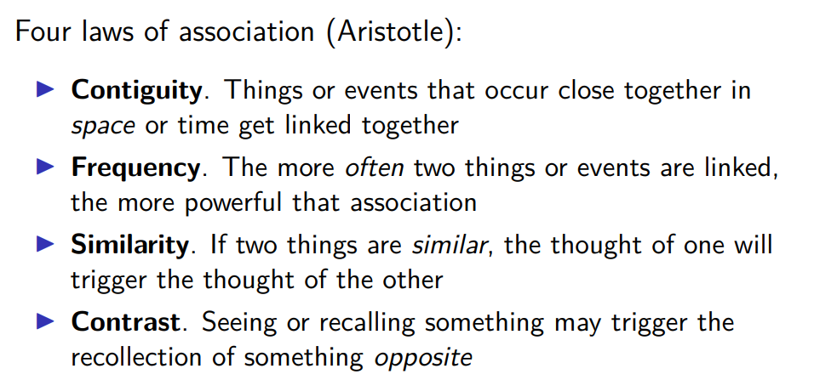

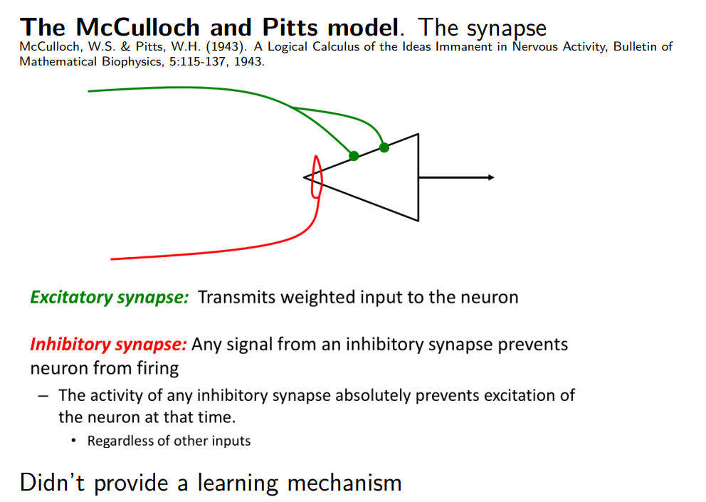

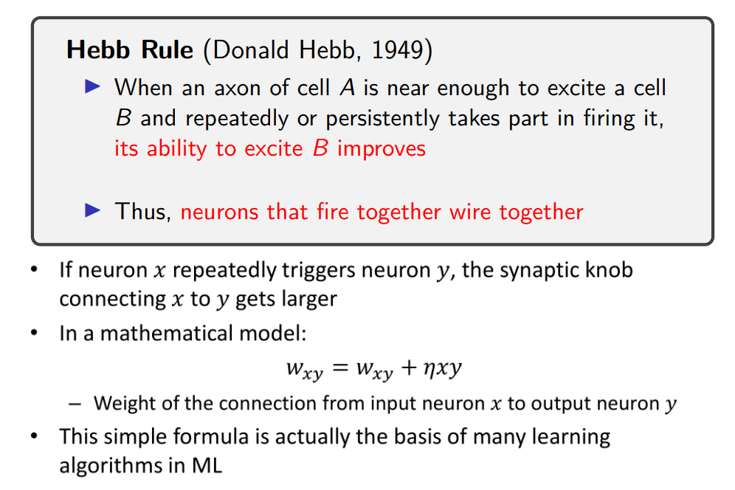

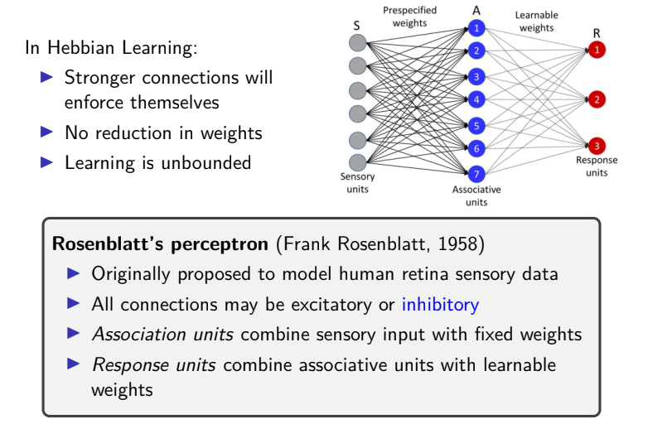

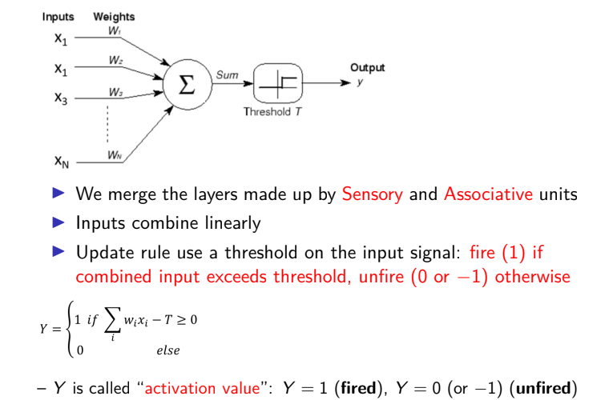

output y can be equally represented
1 for fire
0 neuron does not fire (or -1 in other formulation)

if it richest the threshold the neuron fires, otherwise does not fire

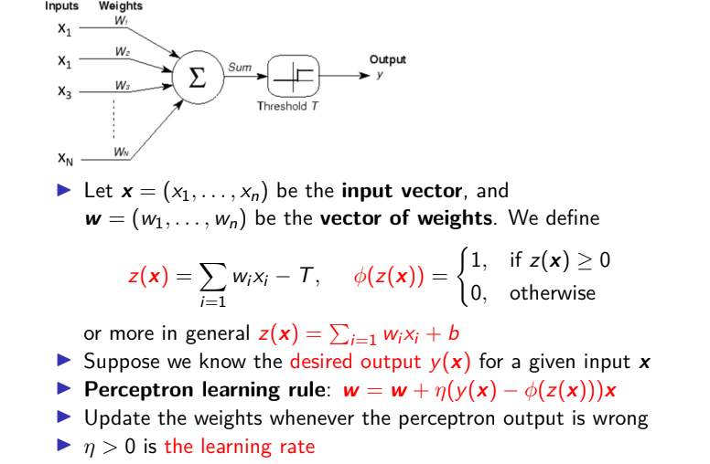

w is equal to the previous value it had + η x and the desired output minus the current output

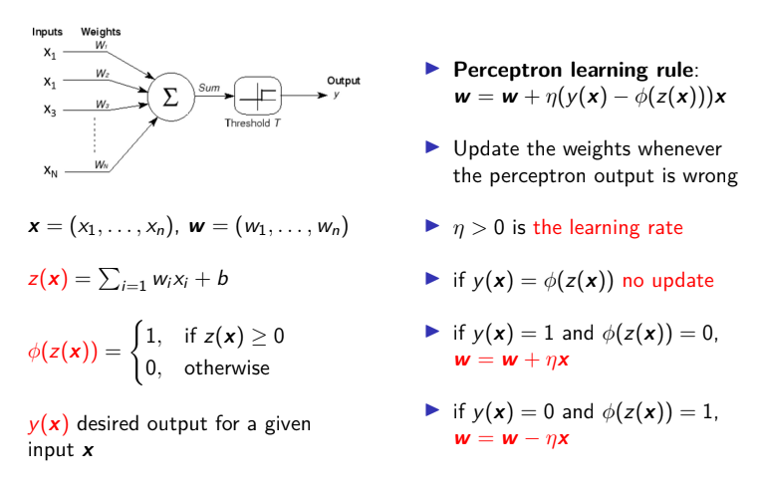
different hypothesis if desired output is 1 and current output is 0 and vice versa

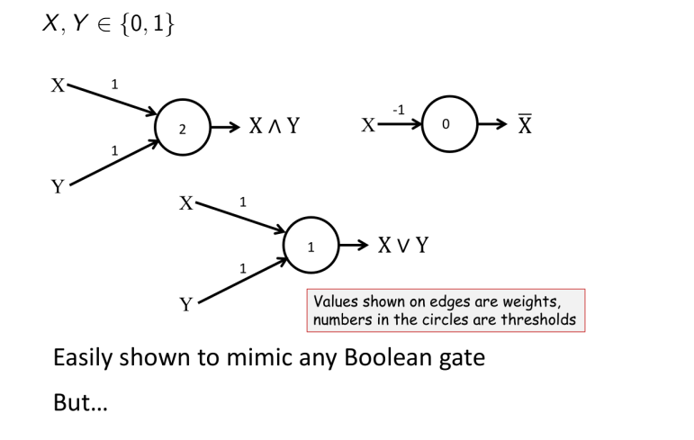
perceptron you can mimic boolean gate
top left AND fix weights equal to 1 and threshold equal to 2. Is 2 only if both are 1 (sum is 2), otherwise is 0.

top right NEGATION negative weight. 0 as threshold, if x = 0, 0 * -1 = 0 and reach threshold ⟹ output 1. If x = 1 * -1 = -1 does not reach threshold ⟹ output 0

bottom center OR both weights equal to 1 and activation also equal to 1.

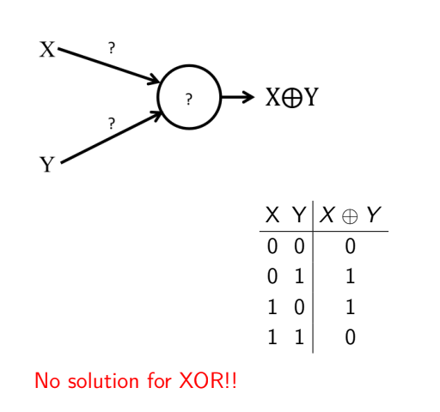
Problem: unable to realize the XOR, can never get this truth-table.

